**Project Overview**

**Problem**

Traditional washing machines are not designed to work in microgravity environments or accommodate for the scarcity of resources on a spaceship. Because of this, there is currently no way of washing clothing in space. As the distance from earth and need for self-sufficiency for astronauts increases, so does the need for astronauts to be able to clean their own clothing.

*As an example of this, astronauts on the International Space Station (ISS) get resupplied clean clothing periodically. The capsule that this clothing is sent up in is then loaded with trash and dirty clothing, and sent back to burn up in the atmosphere.*

**Specific Goal of Design**

Clothing will get dirt and other contaminants entrained within the fabric from the wearer and surrounding environment. The working principle behind removing these contaminants is for a heavier liquid like water to saturate the clothing item where it can free and carry these contaminants out from the fabric through some means of agitation. Dirty water is then removed to leave a cleaner clothing item than when the process started. The most basic implementation of this process involves introducing water, agitating the clothing, and then drying the clothing item to conclude the wash process. Additional steps and phases may be added to address additional components such as the use of detergents or specific considerations to the design and environment.

**Criteria and Constraints**

* Wash process must be operable in a microgravity environment
* Wash process accomplished while not generating excessive vibrations
* Machine must fit into an ISS Double EXPRESS Locker
* Water consumption for a single clothing item must not exceed 1000 mL
* This process also must not utilize high power sinks such as heating elements
* Wastewater produced must be reclaimable by the water purification system
* The system must be automated

**ISS Double EXPRESS Locker Internal Dimensions**

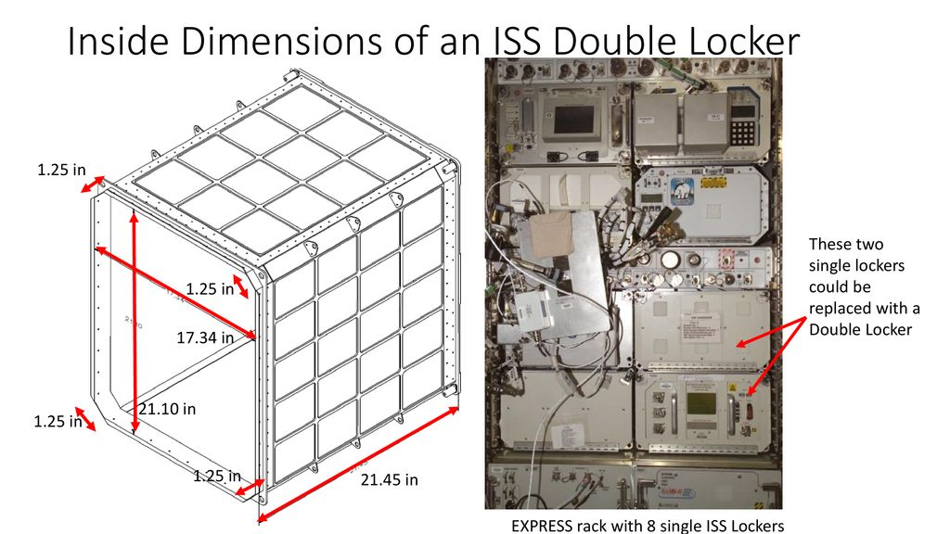

Only one clothing item will be washed at a time, and clothing items may be damp once the wash process has been completed.

**Design Challenges**

Filling and discharging rigid tanks: Sealed, fixed-volume tanks present challenges of liquids needing a mass to displace any fluid exiting the space. On earth this is typically air from the atmosphere, but this presents other challenges

Multiple fluids occupying the same space: Without gravity to naturally separate dissimilar fluids in space, free surfaces between the two mediums will mix and become hard to separate.

Spacecraft Environment: As an extension of the criteria and constraints, the machine must be made to be operable under conditions not usually considered in the design of typical washing machines. This means no centrifugal force or spinning laundry at an offset axis which would generate vibrations, no large drums or spaces which large amounts of fluid can leak from, and no free surfaces of dissimilar liquids without some means of separating them with additional processes.

**Principles of Design Solution**

Agitation, Drying, and hydration phases of the wash process can be accomplished by the compression of clothing done by a linearly actuated piston.

Basic Machine Function

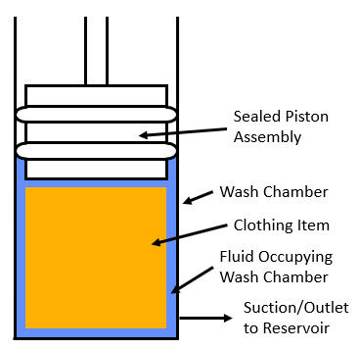

The utility of the piston is used across the wash process in a variety of ways, but there are two main attributes to this function that serves the wash process.

The Use of Compression in the Wash Process

At compression of roughly 32 psi, the compression of a Cotton T-Shirt is high enough to leave the clothing item as dry as it would be if taken out of a standard washing machine.

Uncompressed, a randomly packed clothing item will have folds in it which allow low resistance flow channels for water to pass through. At a compression of roughly 50 psi, a randomly packed clothing item will be compressed enough that the folds are diminished, inhibiting flow and forcing any fluid flow to travel through the clothing fibers. Flushing water through the clothing fibers facilitates agitation.

In a 4-inch diameter wash chamber, the equivalent force of the piston to generate the required force is 600 lbf.

Pumping Action Done by Piston

Using a sealed piston gives the ability to displace and move fluids in a controlled manner. Through the means of simply extending and retracting the piston, pumping action allows for control over fluid motion within the system. Combined with the use of control valves in the piping of the system, control over the fluid types, inlets and outlets, pressure, function, and phase of the wash cycle can all be controlled without the need for additional hardware or built-in mechanisms.

Though compression is a key component of washing a clothing item, the act of creating flow is what drives wash water to agitate and carry away contaminants, making it the most important aspect of the design.

**Design of Machine**

The machine designed to carry out this function would be constructed in the following manner:

[[Need to make a mock-up CAD, substitute design drawings for the time being (also note, rough drawing not up to date with current design)]]

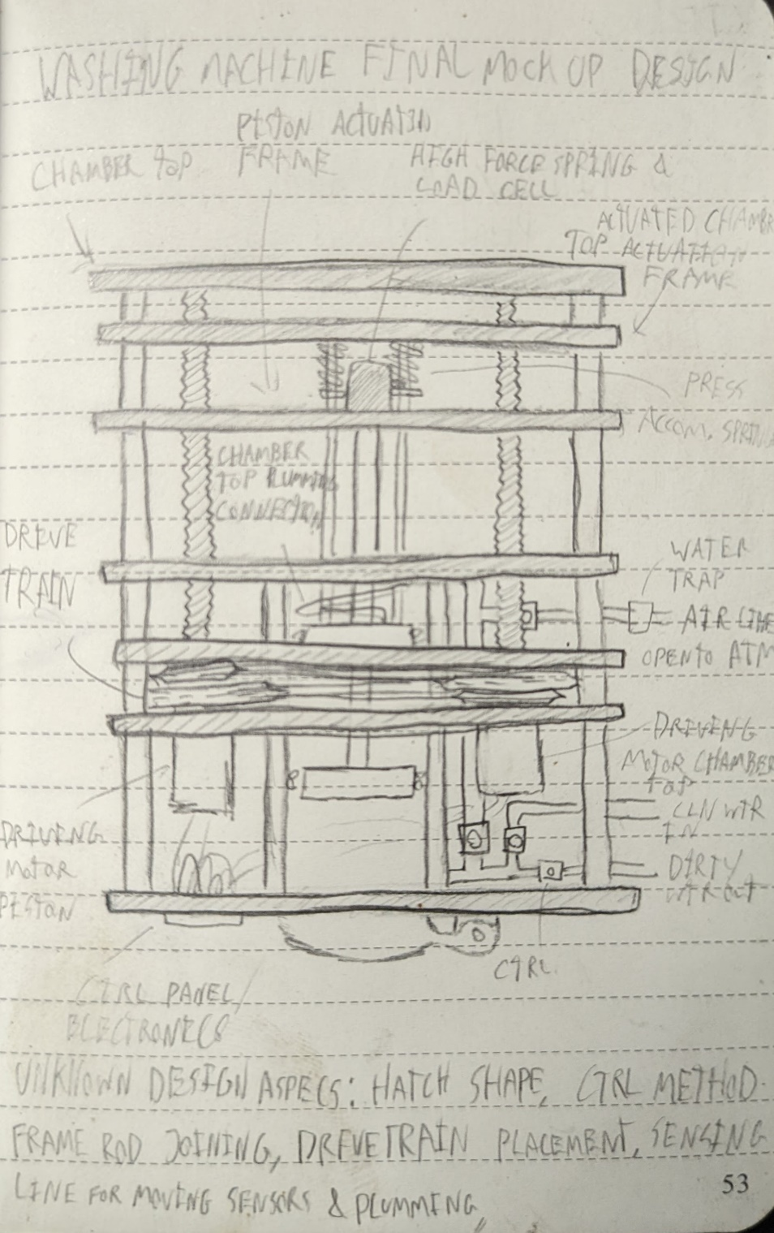

**Notes on Design Components**

The Reservoir: for displaced fluid. This is the space above the piston created when extending into the wash chamber. Since the volume displaced by the piston is the same as the volume created on the other side, fluid can be drawn into the other side of the piston and used as a reservoir without additional components or control systems to account for changes in volume.

Chamber top: The chamber top is a second actuated piston. This is used to alter the size of the wash chamber to accommodate varied sizes of clothing, which will require different volumes of water to wash. Having the ability to change the size of the wash chamber also comes with functions such as pressure adjustment, and the ability to accomplish additional functions within the wash process.

The use of springs in the chamber top are present to account for changes in wash chamber volume as the wash process is carried out. This might occur since the shaft for the compression piston is introduced when extended into the chamber, adding mass to the ideally closed, rigid chamber.

Drive System: This system uses a drive train to convert the rotary energy of a DC electric motor into a linear motion of the piston. The use of a drive train accomplishes the same function as a linear actuator, but takes up less space in the vertical axis, allowing for the size of the wash chamber and piston travel to be maximized. Since actuation of the piston and chamber top assemblies are offset to the side of the location of the reaction force due to compression, two threaded rods are positioned on opposing sides of the wash chamber assembly to maintain the integrity of the assembly.

Piston Head and Force Application System: The piston assembly and force application system is the component used to apply force to the clothing item. Since a key part of operation is to detect position and force application, components such as a load cell and potentiometers are used to measure these attributes and relay the information to the control circuitry for use.

Control Valves and Piping: Valves are actuated through a control circuit allowing for control of fluid throughout the system. Since flow through the system can occur in different directions for a given section of pipe, solenoid valves cannot be used. Instead, servo-actuated ball valves control the flow of fluid through the system.

**Advantages of Design**

Segregation of Dissimilar Fluids

As a result of different fluids never making contact, no consideration needed for free surfaces between dissimilar fluids.

Simple Mechanism

No small or complex components required for operation, making the design easy to maintain.

Rigid Assembly

No complex non-rigid components subject to wear.

Compact size

Since fluids are separated, the volume of the clothing item and the allowed volume of wash water is the maximum allowable size for the wash chamber. This makes the design inherently small when compared with the allowed dimensions.

**Some Notes on Design Principles**

Though force application on the clothing item is relatively high, the fluid occupying the spaces between the clothing fibers does not necessarily experience this load. Any force transferred to the washing fluid is generated if flow is inhibited under the high compression from the piston.

The ability for the compression of the piston to remove water from the wash chamber is dictated by how much the clothing item can be compressed. While the clothing item compressed allows for a minimum chamber dimension, the volume of fluid displaced by the fluid minus the chamber volume is how much fluid is left in the chamber.

Piston compression does not need to be fast, the compression and flow generated by piston movement do enough work to agitate a clothing item, and the rate at which a clothing item is hydrated or dried is not a time-dependent process. If ever a greater flow is required, the use of external pumps can be employed to generate higher flow rates without needing to utilize the piston.

**Unexplored Design Space**

**Agitation Spray Nozzle:** Generating a higher velocity flow rate back into the wash chamber during the decompression in the agitation phase of the wash process. This could dislodge contaminants. This would require an additional inlet pipe and valves to the wash chamber from the reservoir.

**Rapid Fluid Evacuation Check Valve for Clothing Compression:** Simply a larger outlet to the wash chamber that will facilitate a greater flow out of the wash chamber during compression. Would require an additional outlet to the wash chamber.

**Vacuum Drying and Flash Agitation:** Retracting the chamber top to increase the volume of the wash chamber, reducing the pressure of the wash chamber greatly. Using this method could evaporate the water in the shirt, allowing it to dry better. Similarly, this method could be used to cause water to cavitate in the wash chamber, which might agitate the clothing. No additional hardware would be required for this, though current hardware is not explicitly built to hold a vacuum currently.

**Addition of Disinfection Phase:** This is a part of the wash process not included for this prototype, but to develop further, implementing this functionality will be key to making this design viable in a working environment.

**Circulatory Pump for Uncompressed Agitation:** Dislodge solid contaminants which might be locked within the clothing by compression, making flow back into the chamber rather ineffective for this type of contaminant. Additional plumbing as well as wash chamber inlets and outlets must be added.

**Water Ports in Piston Head and Chamber Bottom:** During the wash process, the most effective agitation occurs around the inlet/outlet port to the wash chamber, this is due to the greater flow at these locations. To maximize high flow locations, more inlets and outlets can be added around the chamber. Potential additional locations include on the wash chamber

**Anti-Leak Prewash Check:** Through the use of pressure transducers and air pressure, the system can be checked for leaks by increasing air pressure in localized areas of the piping and then checking to see if the air pressure diminishes as time passes. Through this method, the sealing of the washing machine can be checked before introducing water into the wash chamber

**Foreseen Issues with Current Design**

**Associated Issues with Moving Piston Design:**

No Lubrication:

The direct contact and constant movement of the sealing rigns across the wash chamber cannot be lubricated without contaminating the clothing item. This will create resistance to the machine, potentially generate vibrations and noise, and wear the sealing surfaces. Potential solutions include making piston rings easily replaceable or exploring using detergents that can serve as lubricants in addition to washing clothing items.

Wash Chamber Wear Due to Piston Movement

The fluid being handled by the washing machine is inherently dirty, and can contain contaminants such as sand, which if caught in the sealing surface will score the wash chamber and ruin the piston seals. Potential solutions include adding wiper seals to keep damaging debris from getting caught, and incorporating a routine post wash process cleaning of the wash chamber by running water through the machine to flush it out

**Removing Solid, Non-soluble contaminants:** Since the wash process works by compressing clothing to restrict channels for fluid flow, this also means that contaminants that are not water-soluble and solid will effectively be trapped within the clothing item during flow and compressions. Potential solutions for removing solid, non-soluble contaminants include low uncompressed agitation, where the clothing item has water jettisoned at it by an external pump, reorienting the clothing item and carrying solid contaminants away from the wash chamber.

**Heightened Clothing Wear Due to High Compression:** High and repeated compression of clothing items could generate wear on the clothing item. This could be a disqualifying issue with the design, and testing must be conducted to determine the extent of this perceived problem.

**Removing all fluid from clothing item:** The premise of this design hinges on the fluid occupying the space in the ash chamber being mostly homogeneous. This assumes that all air is evacuated from the clothing item upon compression for the soaking process, which is not possible. In one compression at 32 psi, up to 150 mL of water can be removed from a T-shirt with a fluid displacement volume of 150 mL. This amount of fluid should render the machine operable, but additional processes should be put in place to improve this capability.

**Prototype Testing Plans**

The following experiments will be conducted once the final prototype is made

Wash Effectiveness Test: Test actual capability to hydrate, agitate, and dry clothing

Orientation Test: Test machine in various orientations to verify it works independently from gravity in addition. If the machine works in 1 gravity, and can work in orientations independently from gravity, then in microgravity environments ranging from 0g up to 1g, the washing machine should be operable.

Vibration Generation Test: Find if parts of the wash process generate external forces which would need to be accounted for in later design iterations

Clothing Wear Test: Find how quickly the wash process degrades a given clothing item and determine if employing the design would improve the useful lifespan of the clothing